

**Course title: Advanced Programing**

Airline Reservation System

**Group number: 4**

**Project title: Airline Reservation System**

**Submission date: 18/6/2023**

**All team-member names:**

**Shahd Ahmed Ibrahim Ahmed (sec 2)**

**Hagar Khaled Helmy Hassan (sec 3)**

**Shimaa Samir Ahmed Ibrahim (sec 2)**

**Salma Ahmed El Tayeb Babakr (sec 2)**

**Shorouk Mostafa Mohammed Hassan (sec 2)**



|  |  |
| --- | --- |
| Table OF Content | Page No |
| Abstract | 2 |
| Introduction and purpose | 2 |
| features and functionality of the project | 3 |
| snapshots of the project while running | 4- 22 |
| UML diagrams | 23 |

* **Abstract:**

This report is talking about our implementation for more easier and comfortable airline reservation system

**Table of contents**

1-introduction

2-interface

1-user

1.1 confirmation that he is our client

1.1.1 tickets booking

2-registeration

3-admin

2.1-Add flight

2.2-Delete flight

* **Introduction and purpose**

An airline reservation system is an application built in java with a graphical user interface (GUI) that enables travelers to book and manage their flights with ease. It is a crucial component of the aviation industry that allows customers to search for available flights, pay for their tickets, receive confirmation of their bookings and more.

The app provides users with an intuitive and easy-to-use experience, with it’s simple and easy interference which you can get used to fast it interactively deals with the user until the user request to terminate the program.

the airline reservation system can benefit both customers and airlines by providing a seamless booking experience and streamlining operational for airlines.

* **features and functionality of the project**

**Interface:**

After opening the project, you will be presented with an interface that allows you to choose whether to interact with the system as a user, admin, or first-time guest. If you are using the system for the first time, you will need to register first before proceeding.

**Option 1: User:**

**1-confirmation that you are a registered user.**

We have a file called "User" in which we will search for your name and password to verify your name and password. If the username and password match, the program will continue. Otherwise, you will need to try again or go back to the main page.

**2.1-ticket booking**

Where the user can book a flight ticket, by selecting the departure and destination destination from the available flights. After that, we will search for all available flights to that destination from our “flight” file, and the available options will be displayed on the table, and the flight date that suits you will be chosen

**2.3-** **information about the destination country**

once you click on it, we will display information about that country you selected from a set of files that we designed before called "countries" that contain information about various countries. We will provide you with information about the country you have selected, including some of its landmarks.

**Option 2: registration**

If you are a first time user, you will select this option and you will be asked to enter a username, password and some information about yourself and we will save it in our "User" file, so next time you use our system you will log in as a user.

**Option 3: admin**

When you choose that option, you will have another 2 panel to use:

**1-Add Flights**

As admin you can add flights in "Flight" file you have to add flight name, flight date, destination and some other information about the flight.

**2-Delete Flight**

If you wish to cancel a flight then you will choose this option and we will delete all of its data from “Flight “file.

* **snapshots of the project while running**

**Main Class login: here we have 3 Button(User,Registration,Admin)**

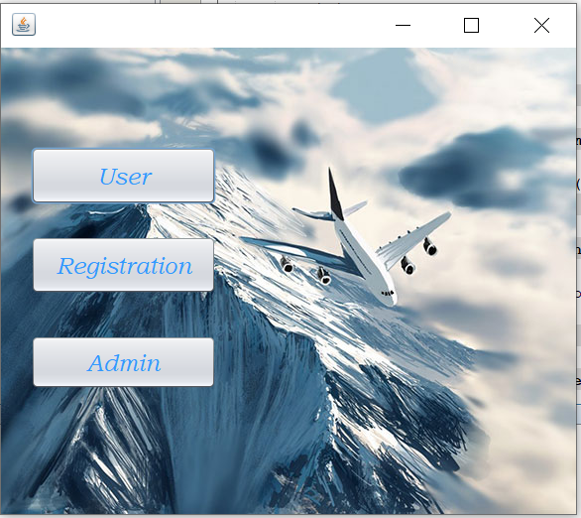

**Main Class login : Clicked User**

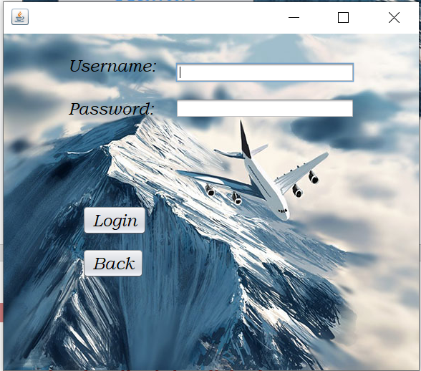

**Main Class login : Clicked User (entered wrong name or wrong password)**

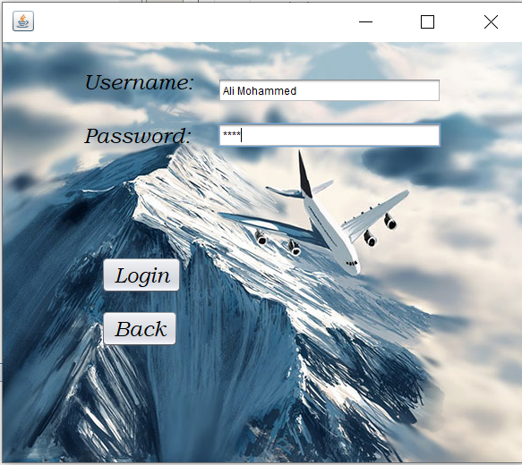

**entered wrong name or wrong password before clicked login**

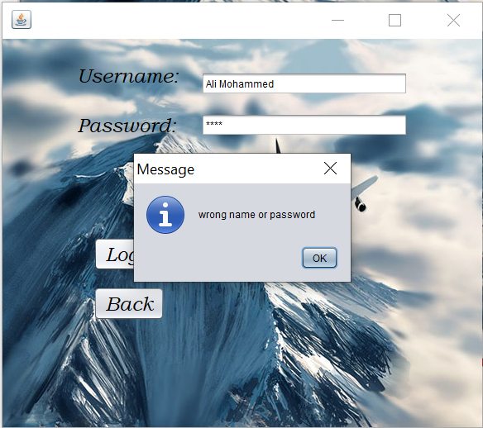

**entered wrong name or wrong password after clicked login**

**Main Class login : Clicked User (entered right name and password)**

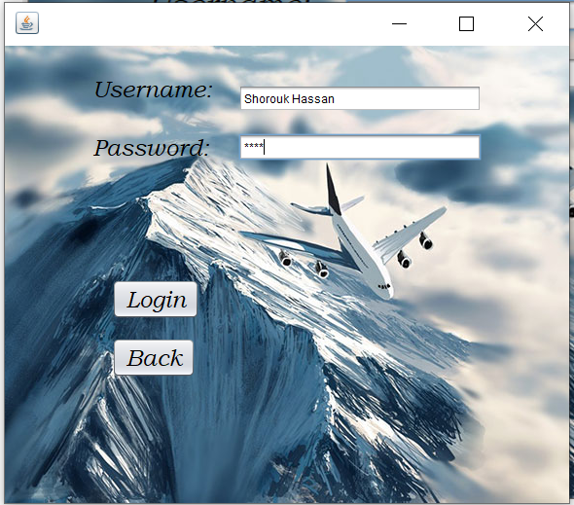

**entered right name and password before clicked login**

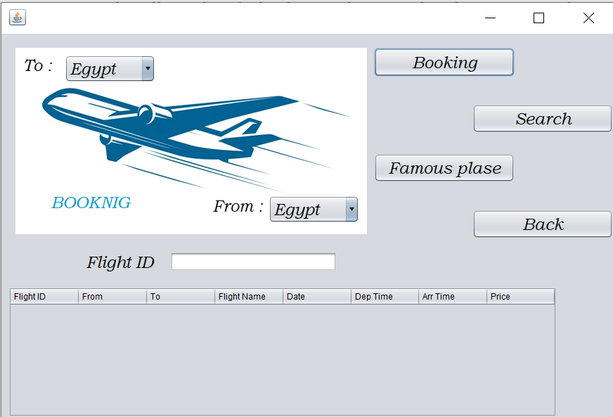

**entered right name and password after clicked login**

**Class Book : here we select from and to county we will travel**

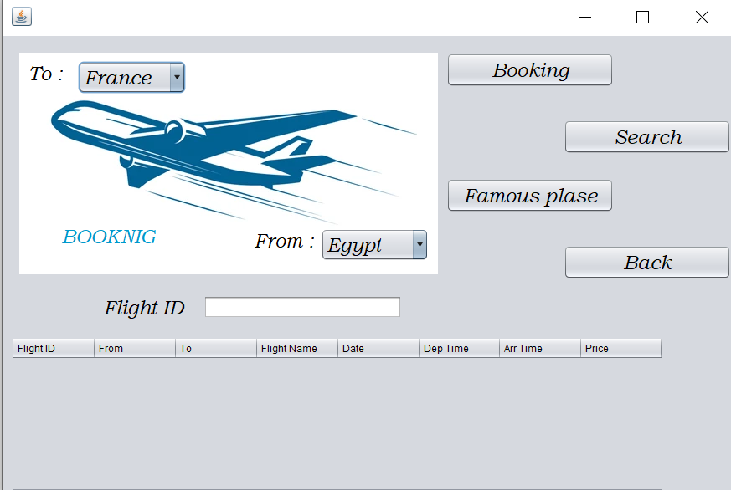

**Class Book : clicked Search**

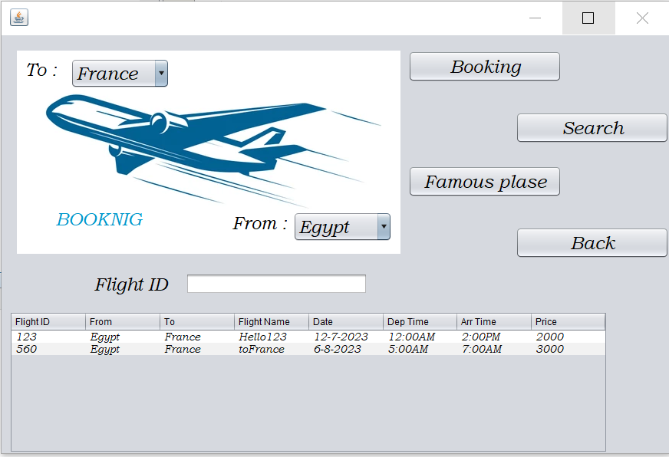

**Show Flight available**

**Class Book : Wrote Flight ID in Text Field after that clicked Search**

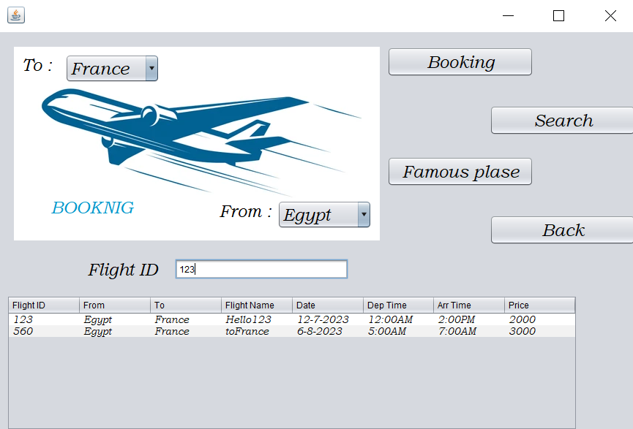

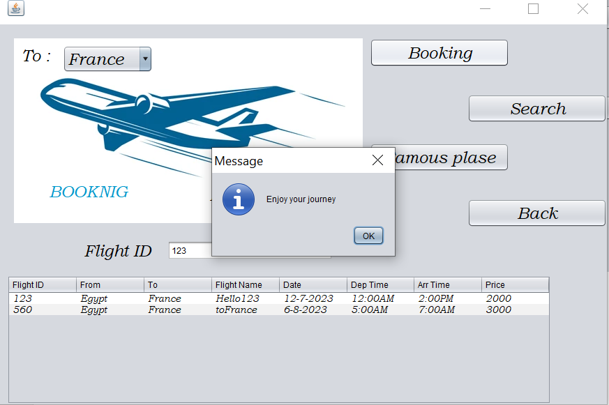

**Class Book : clicked Famous place**

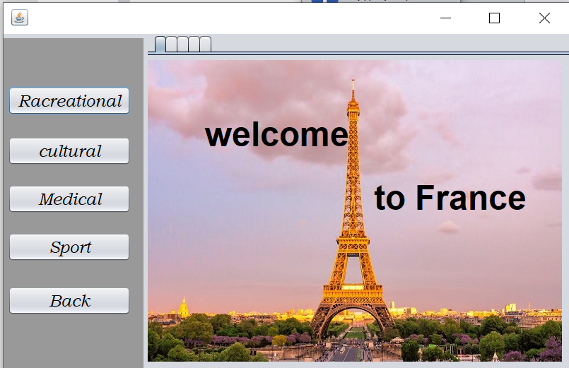

**Class Book : clicked Famous place and clicked Racreational**

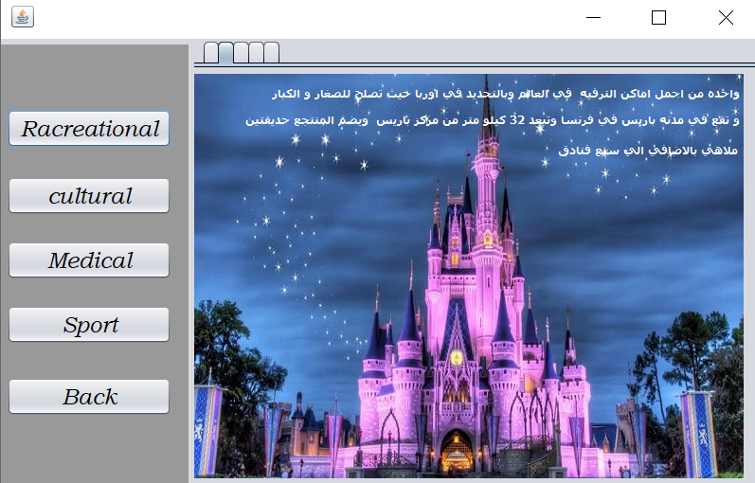

**Class Book : clicked Famous place and clicked cultural**

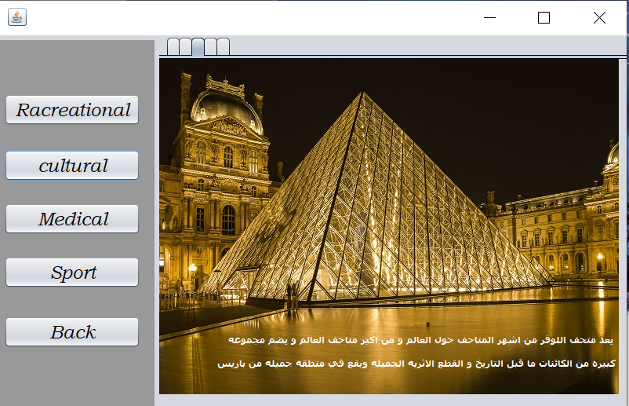

**Class Book : clicked Famous place and clicked Medical**

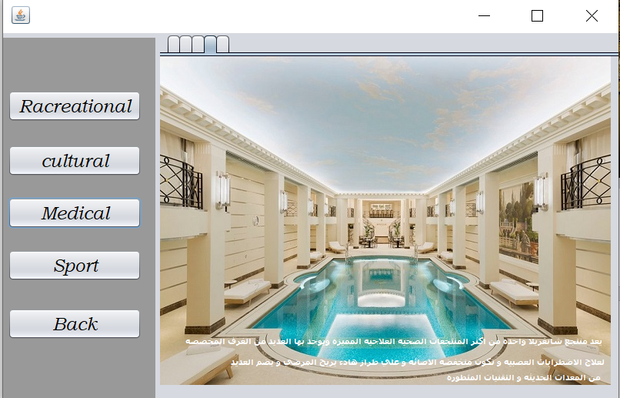

**Class Book : clicked Famous place and clicked sport**

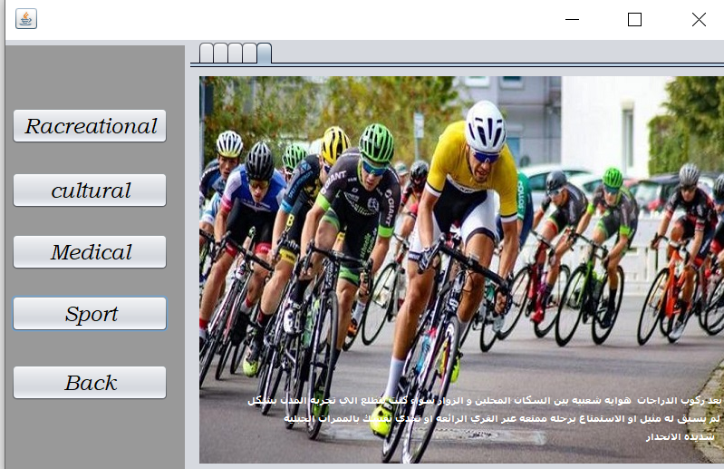

**Class Book : clicked Famous place and Back**

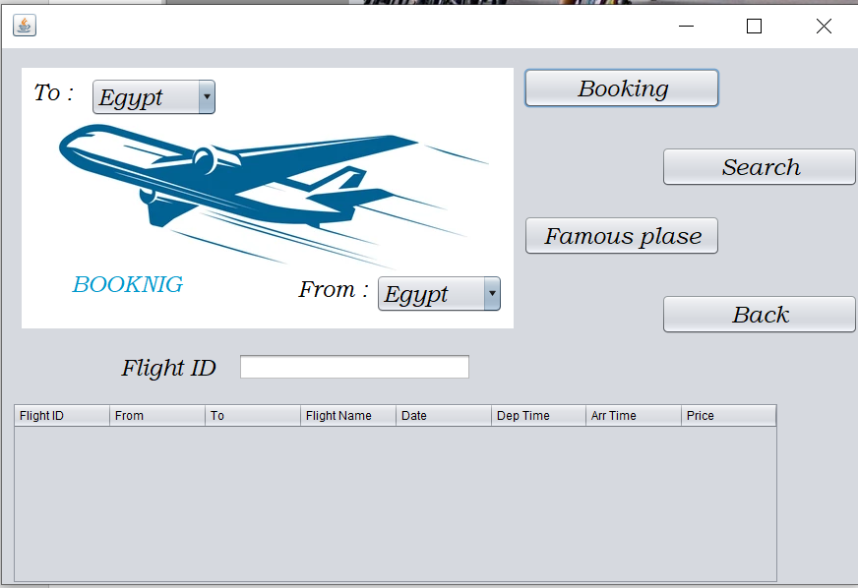

**Class Book : clicked Back**

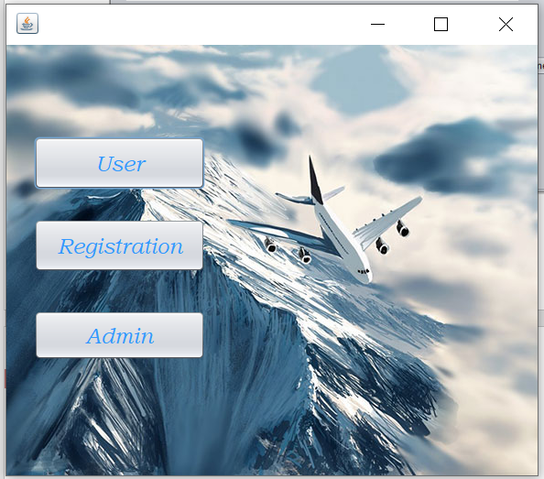

**Main Class login : Clicked Registration**

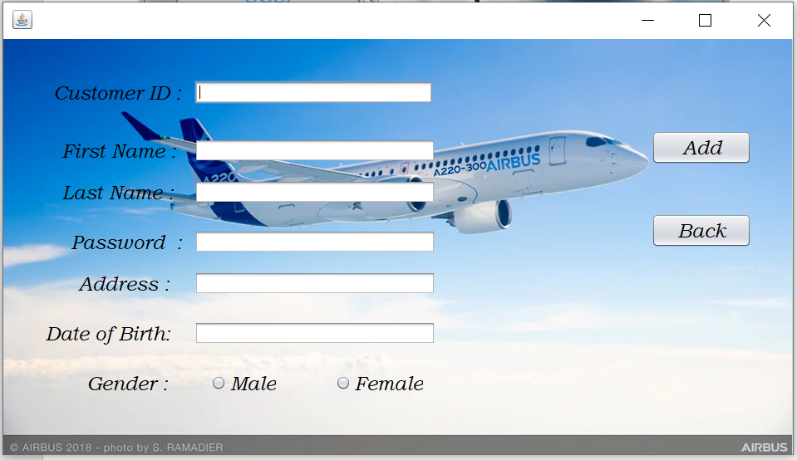

**Registration : wrote information and clicked Add**

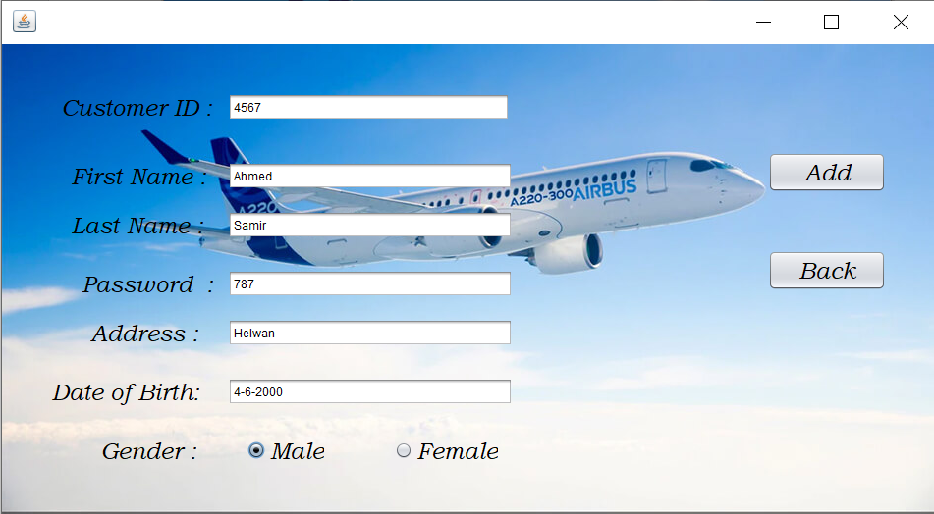

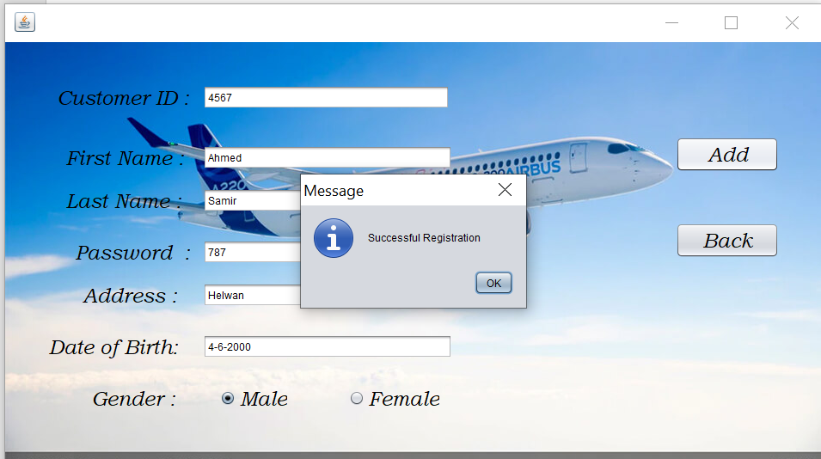

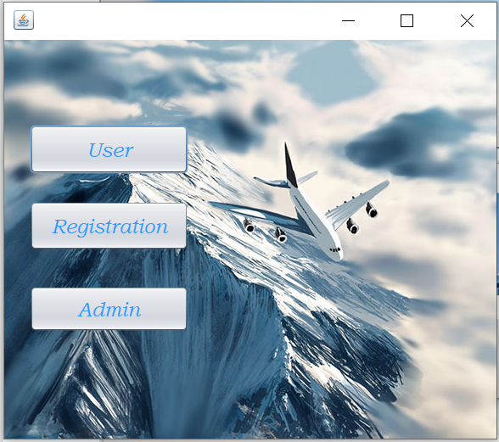

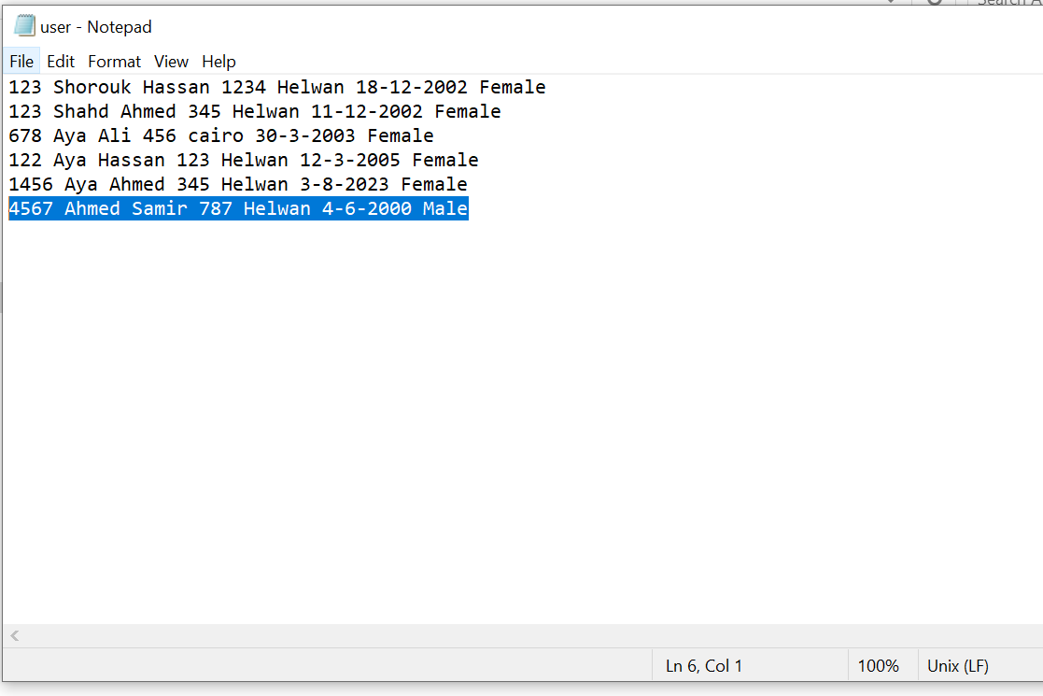

**Main Class login : Clicked Admin**

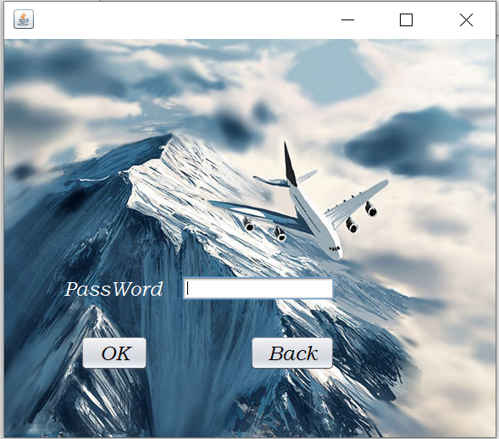

**Admin :Clicked OK after entered wrong password**

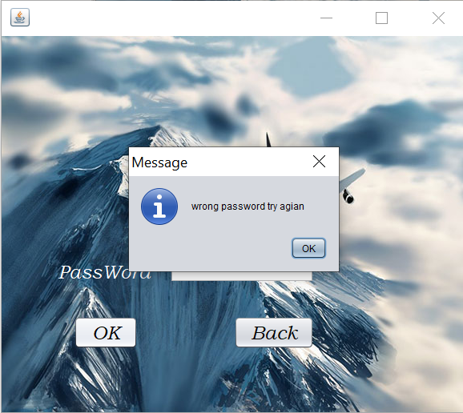

**Admin :Clicked OK after entered right password**

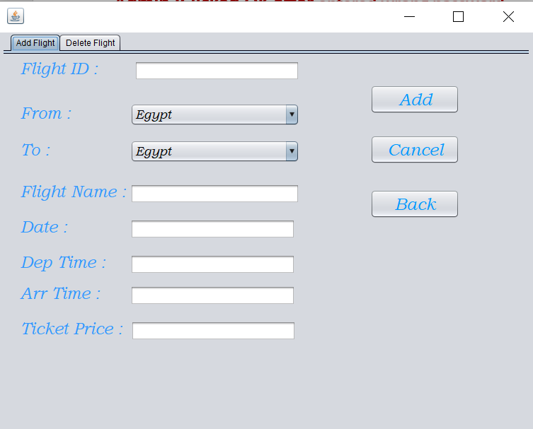

**Admin :Add Flight**

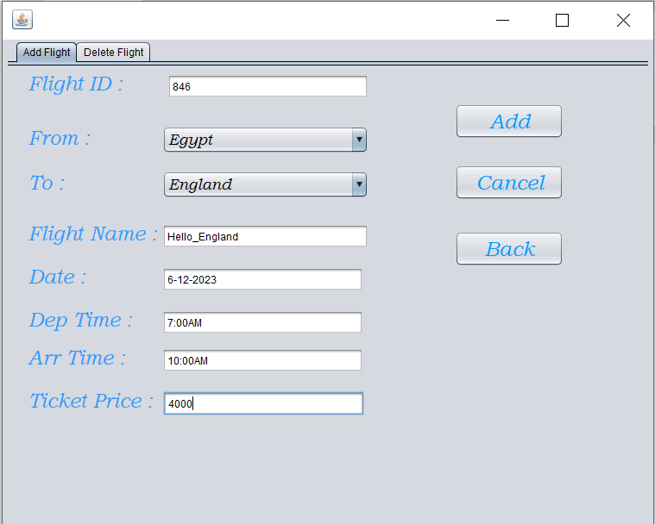

**Admin : Add Flight : Clicked Add**

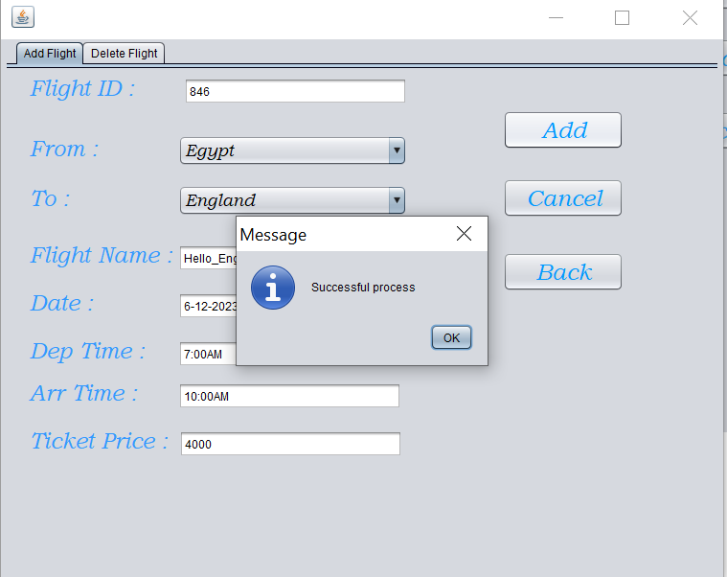

**Admin : Add Flight : Clicked Cancel**

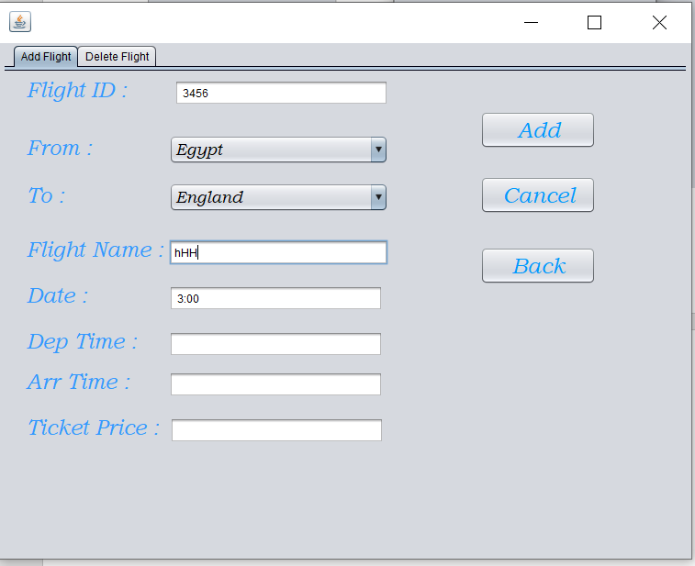

**Before Clicked Cancel**

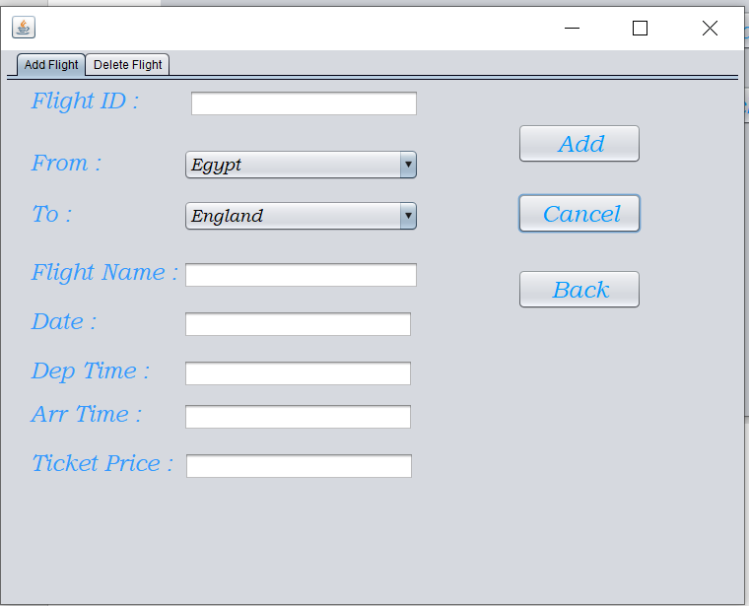

**After Clicked Cancel**

**Admin : Add Flight : Clicked Back**

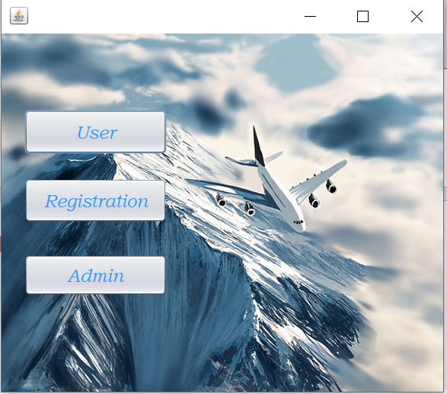

**Admin : Delete Flight**

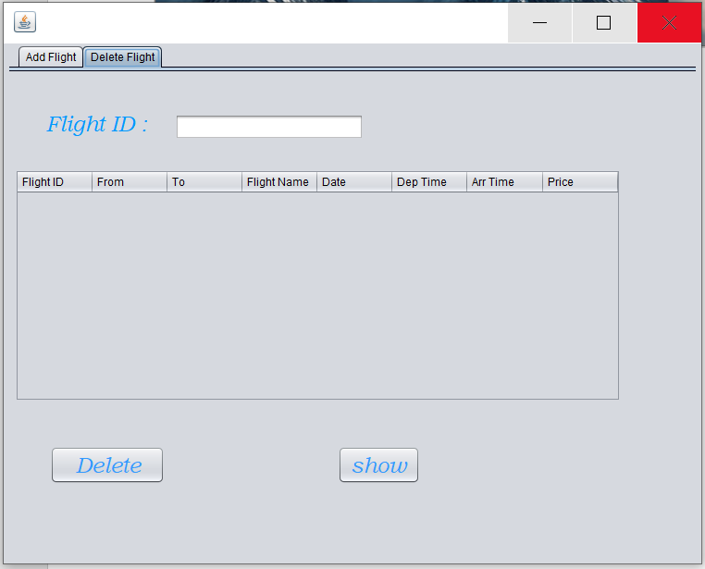

**Admin : Delete Flight : Clicked Show**

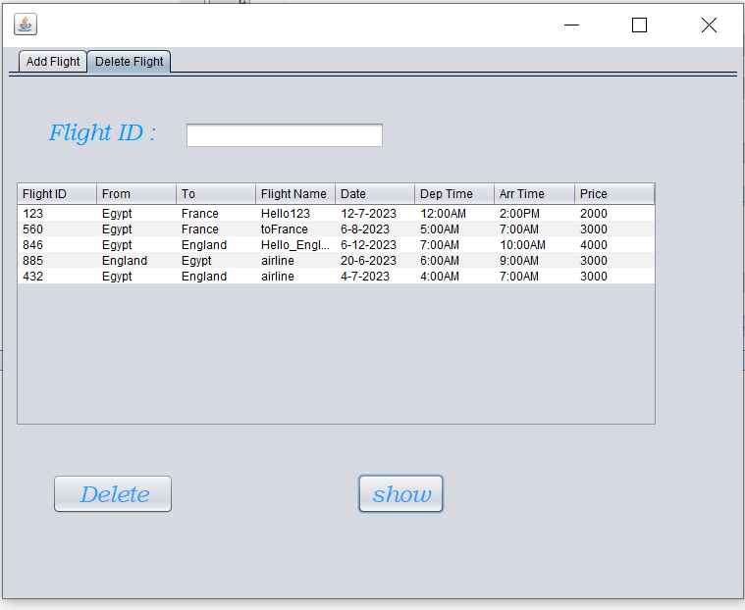

**Admin : Delete Flight : Clicked Delete after enter the right Flight ID**

